Type in paper title here

Enter Authors here with superscript for each to indicate affiliation below^{a)}

(Received: 11 September; Revised: 26 November 2016; Accepted: 4 May 2017)

Enter the Abstract here. This template is merely a tool to aid you in submitting your manuscript. Your final published paper will not look exactly as you submit it as page layout may make it necessary to reposition figures and tables. Before starting your paper, this template should be printed as a reference and all the text beginning after the abstract heading should be deleted. Please keep the following in mind when developing your abstract: Abstract MUST be one paragraph and between 250-300 words. The paper is the authoritative source for the abstract. Footnotes, figures, tables, and equations cannot be included in the abstract (or title).

Primary subject classification: enter primary; Secondary subject classification: enter secondary

1 INTRODUCTION
Enter the introduction to the paper in this segment. The [Head1] style is a Level 1 heading. It has been applied to the d “Introduction” headings. Other levels of headings ([Head2], [Head3], and [Head4]) should be used to structure the content within any given section.
Topics for papers include case histories; instrumentation and measurement techniques; noise and vibration standards; reviews of particular areas of noise and vibration control; and theoretical, computational and experimental methods. All papers should be focused on issues related to noise and vibration control, and should bring something new to the noise and vibration community.
Generally, this segment will provide an overview of the paper. It should outline the major themes and important aspects to be reported. In some cases it may be appropriate to preview the final results or the directions that the conclusions will take to prepare the reader for the basic approach and consequences to be discussed in the paper.
This section may also cite or reference previous work that leads to this work or which provides a foundation for the topics to be discussed. In some cases, a brief history with a description of the work that has proceed what is to be reported is helpful to the reader. This discussion may set the context for the findings and discussions to be presented in this paper if is building on previous work by these authors or others.
While not research focused, case histories are very welcome because they facilitate understanding of how to put noise and vibration control into practice and highlight potential pitfalls for both more and less experienced noise and vibration control engineers.

^{a)} Author affiliation here; email address.

2 Heading 2 - Experimentation
The body of the paper should include detailed and structured description of the work performed, including (as appropriate) methodology, assumptions, hardware, observations, analysis, and a comparison of results with prior work. The information presented must be self-contained (in the sense that the reader is not assumed to have read prior papers) and provide an appropriate level of detail for the intended audience. Define all terms at first usage and apply them consistently.
The body section is not entitled “Body.” Rather it comprises multiple sections and subsections titled using topical headings in a four-level structure. Template styles [Head1] through [Head4] are used to tag and format titles of the different levels. No specific heading titles are mandated, but common examples include Methods, Results, and Discussion. A series of experiments were conducted to evaluate the noise characteristics of widgets in an underwater environment.

3 Heading 3 Example
Typically this heading would be used as subsection to the segment identified with a Level 2 Heading. It could represent a step in a process, a different experiment, or some other separation that needs to be defined for clarity.

4 Tables
An example of a table is shown in Table 1. Tables may fit in a column or bridge the columns if necessary for clarity or to accommodate the number of columns in the table. Tables must be inserted in the body of the text, not provided separately.
Table titles are placed above the table as shown in Table 1. Tables should be one item and should not span more than one page. They should be Word tables.

5 Figures
Figures are handled in much the same way as tables. Figure 1 shows an example of a photograph as a figure bridging the columns. Figures must be inserted in the text and cannot span more than one page. Should there be a need for a figure to span more than one page, it should be divided into two figures and treated as such. Do not separate figures from the body of the document or submit them separately.
A primary difference between figures and tables is that the captions for figures are placed below the figure. Figures

6 Equations
Equations should be inserted in the text with equations numbers and the terms of the equations defined immediately below the equation. These equations must be done in Word. They cannot be images done elsewhere and posted in the manuscript.
Here is a good example of the use of an equation: “…………In the final stage of the calculation of tonality (T), the tonal component (w_{T}) and the noise component (w_{Gr} ) are combined in the following manner:
(10)
where the exponents β and γ are determined by fitting this model to experimental data. The exponent β in Eqn. (10) was estimated to be 0.39. The derivation of equation (10) can be found in ……..”

7 Determining Required Sound Power Level Emissions to Protect Miners
If one is to take this approach, the first steps include determining the sound power levels of existing equipment and the maximum allowable sound levels to protect underground miners’ hearing. NIOSH has a long-established recommended exposure level (REL) of 85 dB(A) for hazardous noise for an eight-hour shift. Therefore, this is the target exposure level for this study.
As noted before, mining environments are very diverse. The acoustic environments of room-and-pillar coal mines, longwall coal mines, metal-nonmetal hard rock mines, and other types of mines are quite diverse. The shape and size of the mining sections are different. The acoustic reflectivity of mine surfaces vary greatly between coal and hard rock mines. Finally, the machines and how they are used are different in different mine environments. Therefore, the method proposed is to use a simple model of typical mine environments and calculate the maximum allowable sound power levels as a first step goal for quieter machines. As the process progresses it may be possible to define better limits with underground data and more experience by researchers.
The approach chosen is to use the classic room acoustics equation to determine the allowable sound power levels in four typical mining scenarios. The room acoustics equation is shown below.

(1)
where:
= sound pressure level, dB(A)
= sound power level, dB(A)
Q = the directivity of the source; 1 will be used in this case
r = the distance from the source to the receiver, m
R = often called the room constant
α = the average sound absorption coefficient for the room or mine surfaces
S = the surface area of the room or mine surfaces
Rearranging this equation one obtains the following using Q = 1 and r = 1.

(2)

To carry this computation further one must know the surface area and the absorption coefficient of the mine. For this purpose some typical mine dimensions have been established as shown in Table 1.

8 citations
- In text – Fig. #, Table #, Eqn. (#) and Sec. #. Spell out if start is starting sentence.
- Reference in text – superscript, inside punctuation, e.g. here⁵. – not here.⁵ In reference list – number, period, tab, e.g. '1. F. Surname....'
- References in reference list – Paper titles in single quotes, book title in italics, vol. no. – bold, journal name – italics, year in parenthesis at end, all else normal font in this order – author, title, journal, vol(issue) or book publisher and place, page numbers and (year). Separated by commas, with comma outside title quotes, e.g. F. Surname, 'The way life is', J. of Life, 75(3), 309–400, (2012).

9 Acknowledgments
This section if for the authors to recognize other contributors, supporting agencies, etc. that were significant help in the development and publication of the paper and the work contained therein.

10. References
1. “Acoustics description and measurement of environmental noise — Part 2: acquisition of data pertinent to land use”, International Standard ISO 1996 2, (1990).
2. V. Nitsche, “Application of aircraft noise monitoring systems at German airports”, in Proc. INTER NOISE 95, Eds R.J. Bernhard and J. Stuart Bolton, Noise Control Foundation, Poughkeepsie, New York, (1995), 2, 755–758.
3. B. Widrow and S.D. Steams, Adaptive Signal Processing, Prentice Hall, New Jersey, (1985).
4. A. Donut, “Reduction of noise of deep fryers in fast food venues”, Journal of the Acoustics of Food Production 10(3),77–79, 1981.
Table 1—This is an example of a table.
Table Head | Table Head
Displaced volume | 1966 cc
Stroke | 154 mm
Bore | 127.5 mm
Connecting Rod | 255 mm
Compression ratio | 14.3:1
Number of Valves | 4
Exhaust Valve Open | 34° BBDC @ 0.15 mm lift
Exhaust Valve Close | 6° BTDC @ 0.15 mm lift
Inlet Valve Open | 2° BTDC @ 0.15 mm lift

Table 2—Responses of the employees to the questionnaire.
Question | Response (%)
Question | Yes | No
Is the noise level high at your working place? | 90 | 10
Do you need to shout to make yourself heard at work because of noise? | 50 | 50
Do you have any social problems associated with hearing loss? | 30 | 70
Are you exposed to high noise levels at the maximum? | 90 | 10
Is your hearing abnormal? | 35 | 65

List of Figure Captions
Fig. 1—Time data of the forces measured by the instrumented bit.
Fig. 2—Power spectral density of the force measured by the instrumented bit.

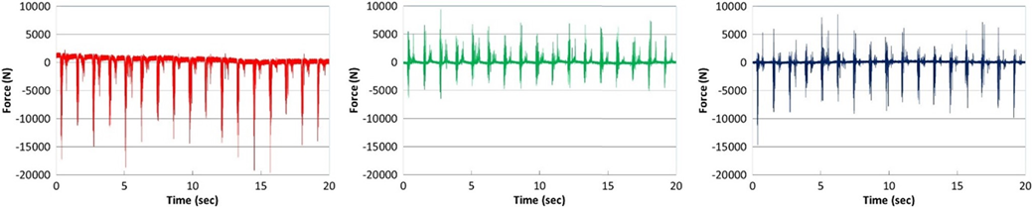
Fig. 1—Time data of the forces measured by the instrumented bit.

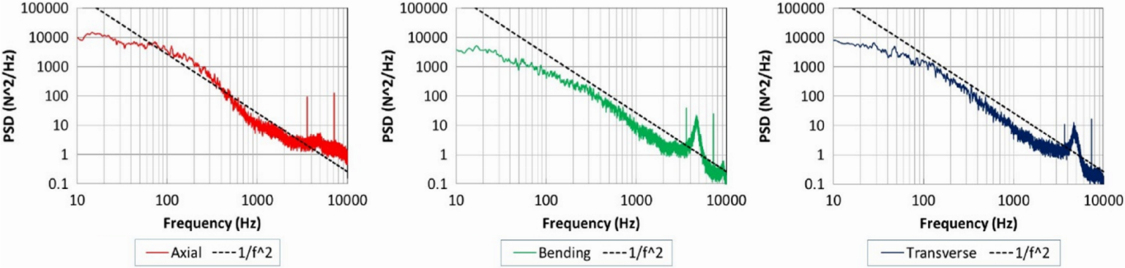
Fig. 2—Power spectral density of the force measured by the instrumented bit.

